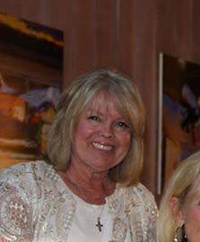
Biography
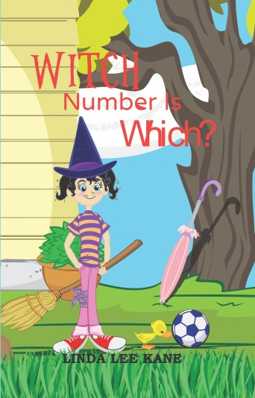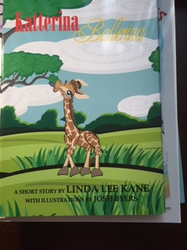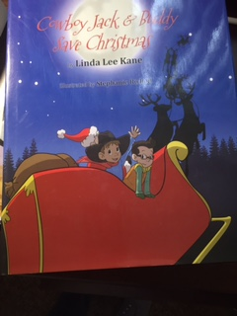

Children’s Books
Linda L. Kane MA in Education, PPS, School Psychologist, and Learning Disability Specialist, is the author of Witch Number is Which, Icelandia,
Katterina Ballerina, Cowboy Jack and Buddy Save Santa, and Chilled to the Bones. A 2018 release date is set for Clyde to the Rescue. She lives with her husband, three dogs, one bird, and eight horses in California.

Linda L. Kane MA in Education, PPS, School Psychologist, and Learning Disability Specialist, is the author of Death on the Vine, Chilled to the Bones and an upcoming release of the The Black Madonna. She lives with her husband, three dogs, one bird, and eight horses in California.

Longer (The above added with below)
The sky is bigger, the ground harder, the freshly grown produce amazing, and the people diversified where I live in sunny, make it very sunny, Fresno, California.
We moved here with little to no expectations except to move back to our hometown of Huntington Beach within 5 years. Thirty-nine years later we have grown to love our home in the San Joaquin Valley, the people, and the opportunities that were afforded us.
Today I write and edit, paint, play with my two grandchildren, my three dogs, ride my Saddlebred horses and drive my Hackney pony, rescue animals that have lost their homes and enjoy life to the fullest.
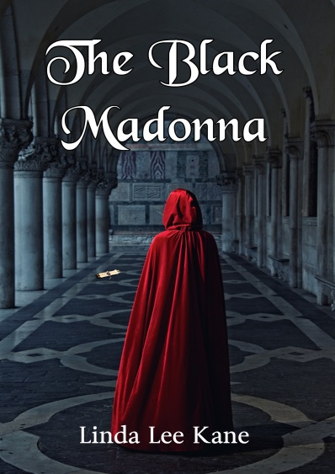
The Black Madonna
The book had been a gift from her grandparents, but it was likely to get her killed…

Looking up, Luci spotted the monk standing on the third-floor balcony of the Center. He seemed frightened. He turned and looked behind him as if he was listening to someone. Then he faced back toward the railing, made the sign of the cross, and pitched himself forward.
“No!” Luci screamed.
He landed, arms outstretched, on some metal spikes jutting out of the concrete slab. Luci saw that, in his hand, he was still holding the tarot card. It was the card of Justice. Luci began to hyperventilate. She tore herself away from the horrible sight and scanned the crowd, searching for Janet. She couldn’t see her anywhere. The ambulance and fire truck were arriving. Too many people, too much noise. Luci could barely breathe. She saw Janet walking out of the library. Luci grabbed a sack of the birdseed that she always carried to feed the birds on her break. Dumping the seeds out she began to breathe into the paper bag. How could the monk have known about the book, and why had he wanted it enough to die? Her skin went clammy, as she fought for breath.
The paramedics raced over to the monk and immediately pronounced him dead. Someone pointed out Luci to the second paramedic. He saw that she was in distress, raced over to her, and slipped an oxygen mask over her nose. “Breathe,” he said.
She could hear people off in the distance. Someone said, “I think she’s having a heart attack.”
“Don’t go to sleep,” the paramedic said. “Stay with me and keep breathing.
The last thing she heard before the ambulance door closed was Janet’s harsh whisper near her ear. “Don’t think you’re getting out of going to France, Luci.

Death on the Vine
Just before high school graduation, Daisy Murphy returns home from a football game and finds her mother standing over her abusive boyfriend’s body—holding a bloody hammer. In the aftermath, Daisy flees her home and eventually establishes a new life as an expert winemaker in the Central Valley of California. But as hard as she tries to get away from her past, the effects of that horrible night travel with her.
Detective Jake Frisco has unearthed a murder at the vineyard where Daisy is employed as the winery’s expert winemaker. It doesn’t take long to discover that Daisy is haunted by her past and carries a heavy burden. It seems that possible involvement in an unsolved murder is part of her life’s baggage. Does this put Daisy at the top of the suspect’s list? Can he put aside his growing feelings for her and follow the leads in the case, even if they take him straight to her as the murderer?
Can Daisy finally face her past and trust that the truth she offers the Detective will be enough to save her? Will she find the courage to ask for a future beyond the sorrow of her youth—a future filled with love and self-worth?
Chilled to the Bones
A Ghost Story
Down in the deepest part of Melville High School two ghostly specters were holding the Devil’s Bible, chanting, “We give our blood so our master can gain strength; we give our blood so our master can gain strength. We are here to serve; we are the devoted, the chosen.”
Flopping down on the dirty floorboards, she ran her hands along the antique’s smooth, uneven edges. It was an old Revolutionary War trunk that bore a metal label with the year 1776 and Robert Townsend I inscribed on it. This trunk was way old; it had belonged to her great-great-grandfather to the umpteenth degree. The magnitude of her discovery was almost unfathomable.
Overcome with elation as the discovery bubbled on the verge of hysteria, Dealer glanced around to make sure she was alone. Her find was worthy of Sherlock Holmes, and it had apparently been hidden in her family’s farmhouse for centuries.
Brushing away the dirt and grime that covered the chest, she realized that it was locked. For a moment, discouragement settled in — but just for a moment. Her eyes scoured the fairly large space for some type of tool to open it. Dusty, faded orange-colored draperies as thin as paper allowed light to filter in
Empty bottles sat on a shelf, the resultant artwork probably long gone. Boxes and long-forgotten personal treasures littered the corners. Dealer ran her hand along the unpainted wood, dirt and dust collecting under her fingernails. where a once-used roll-top desk stood. It was littered with pieces of fabric and paints, colored pencils with leads worn down to nothing, an old pin cushion, it’s sawdust insides spilling out its seams — and an old metal letter opener. It was Dealer’s best bet for breaking open that lock.

Determination wasn’t enough. She knew nothing about locksmithing, and the lock was stiff and slightly oxidized. Decoding the levers with a letter opener would be impossible. She gave up and sat back on her legs to think of another solution. The trunk was a family heirloom so taking a hammer to the lock was not an option.

Slowly Dealer worked to unfold her tingling legs. There had to have been a key. Where was it? She went back to her mom’s desk and sifted through the debris. The feel of the dust made her skin crawl with frustration. She couldn’t find a key. All manner of trinkets, pieces of wood, bits of candles, and colorless ribbons were strewn in the drawers. The bookshelf held even more unorganized junk. There were old papers and books piled in confusion. Moving aside a book on photography, Dealer had a thought. Her mom always kept special things — Grandmother’s cameo, her first baby tooth, Dad’s college graduation ring — in her glass button jar. But where was it? It had been years since she’d seen it.
Just out of the corner of her eye Dealer spied a woman in black lace gliding by the Revolutionary War Trunk, the hairs on the nape of Dealer’s neck stood up, she turned to look at the woman but she had vanished.

